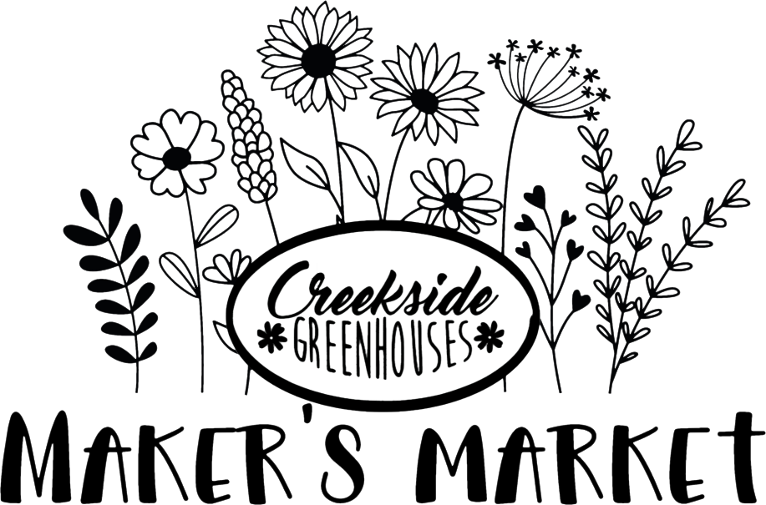

Saturday, May 17th, 2025
Show Time: 9:00am to 2:00pm
(Set-up begins at 7:30am)

Major change to the vendor application process in 2025! Please read carefully – Our application window will be open from February 15th, 2025 through March 10th, 2025. On March 15th, 2025 we will notify the applicants that we feel are the best fit for our market via email, we will include an invoice that will need to be paid by March 31, 2025 otherwise you will forfeit your space.
After March 15th, we will start a waiting list of potential vendors. Your application does not guarantee a spot in the market! A vetting process will determine acceptance.
Exclusivity is not guaranteed to any one vendor. Precautions will be taken to limit duplication of similar items and spacing vendors appropriately.
This is a market designated for those who produce their own goods, produce, craft or items. This is NOT a “reseller” market. Please note that we do not accept vendors selling any flowers/plants/succulents since this market is at a greenhouse. Vendors must exhibit products represented in the application submission.
Booth space will be $30.00 for a 10x10 space. (Food trucks will be setup in the food court) Vendors MUST provide their own tent, chair and table(s). There is No access to power or WIFI. You must set up in your designated area. Market will happen no matter the weather conditions. A ST19 form will need to be completed. (Any food vendors will have to provide the appropriate documents for food licensure: Cottage license, Food Handling license, etc.)

